**Deployment ASSIGNMENT -1**

**Task 1:**

Configure IIS in your local machine

* + Click Start, point to Settings, and then click Control Panel.
  + Double-click Administrative Tools, and then double-click Internet Services Manager.
  + Click Action, point to New, and then click Web Site.
  + After the Web Site Creation Wizard starts, click next.
  + Type a description for the Web site.   
      
    This description is used internally to identify the Web site in Internet Services Manager only.
  + Select the IP address to use for the site.

**Task 2:**

To Check IIS Configuration go to Run and type inetmgr

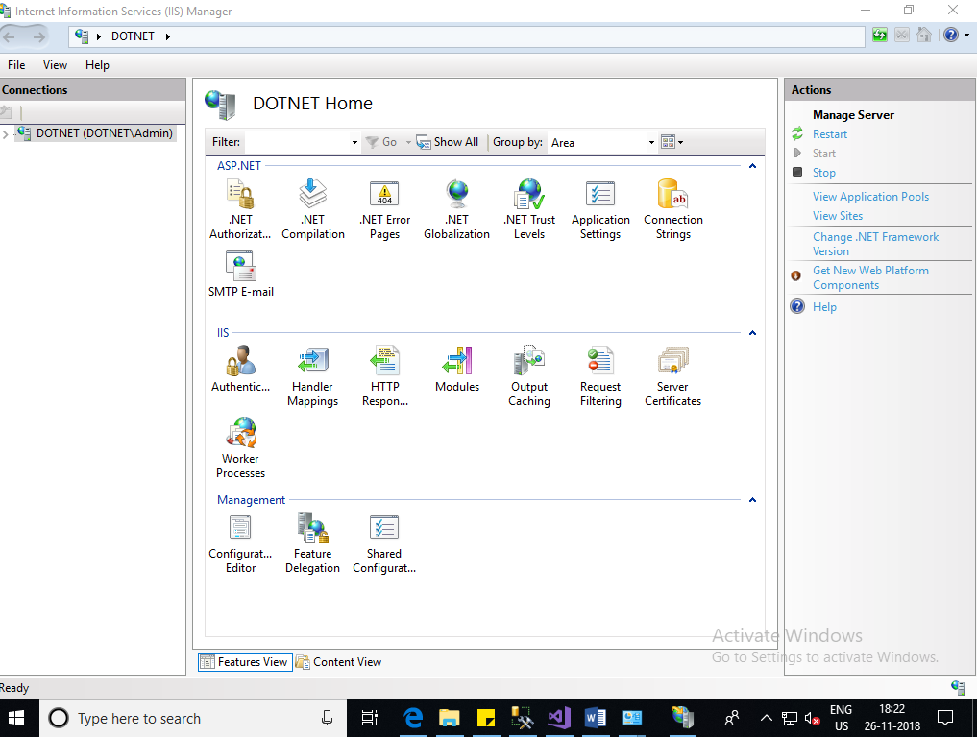

**Task 4:**

Deployed WCF_service application which you created in assignment_21

**Host the service in IIS**

**Steps:**

1. Type IIS in start search box and open
2. IIS will open as below

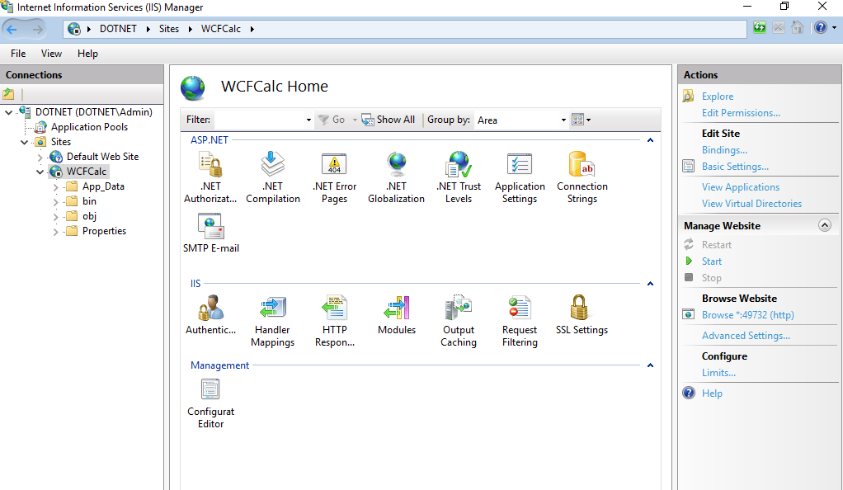

1. Right click on Sites folder and Add new website

Add Physical path and port number and click Ok

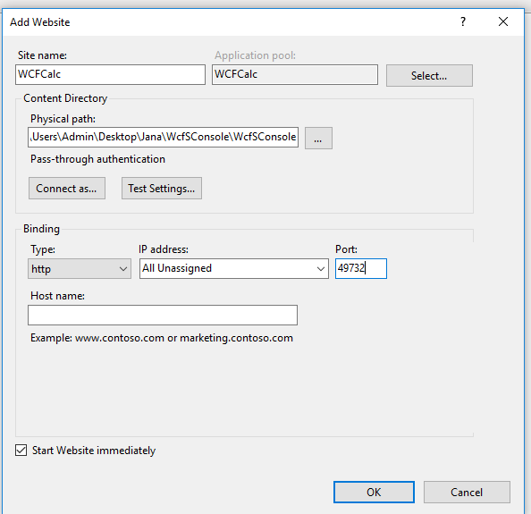

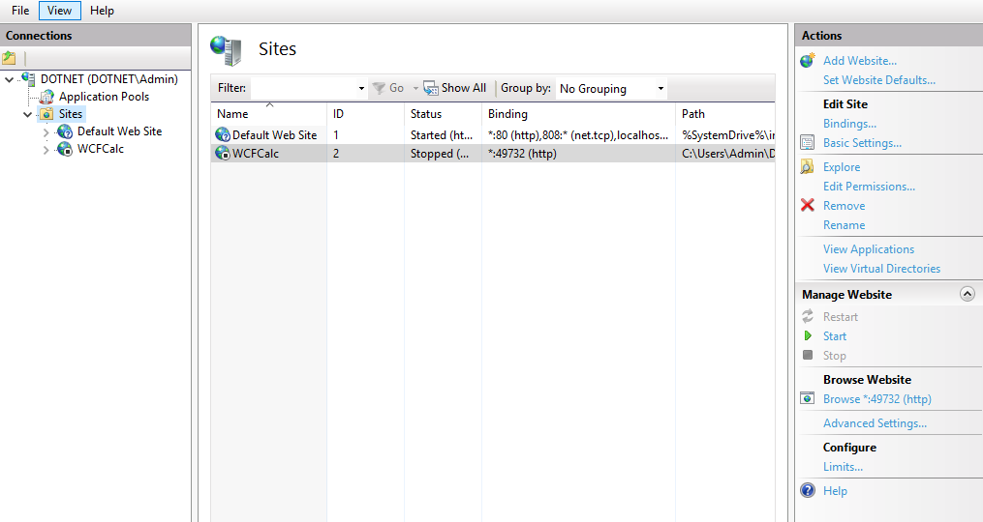

Select WCFCalc website and click browse button

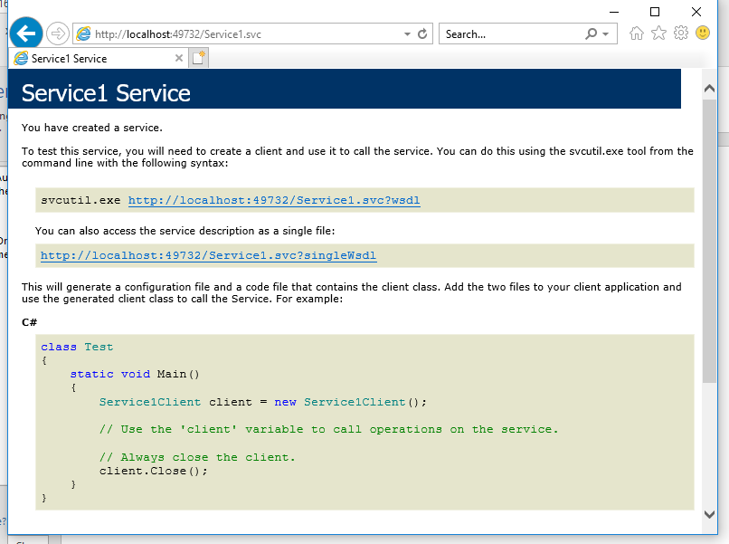

**Output:**

Sayhello program

Currentday-Monday 29.10.2018 18.15

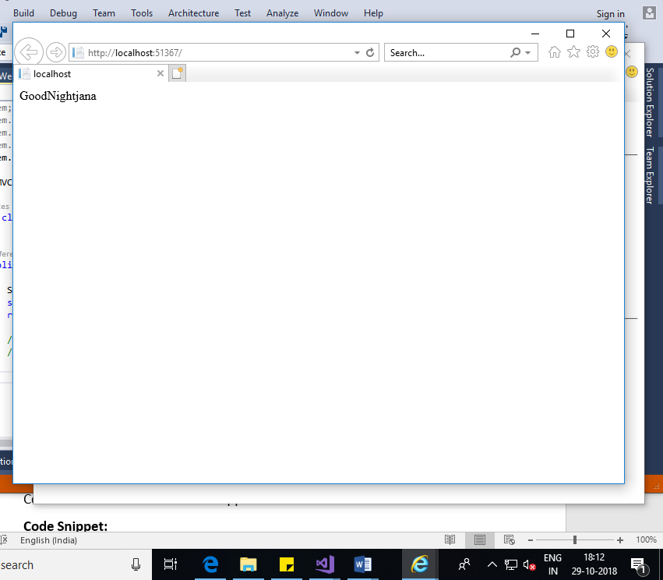

TodayProgram output

Currentday-Monday 29.10.2018 18.15

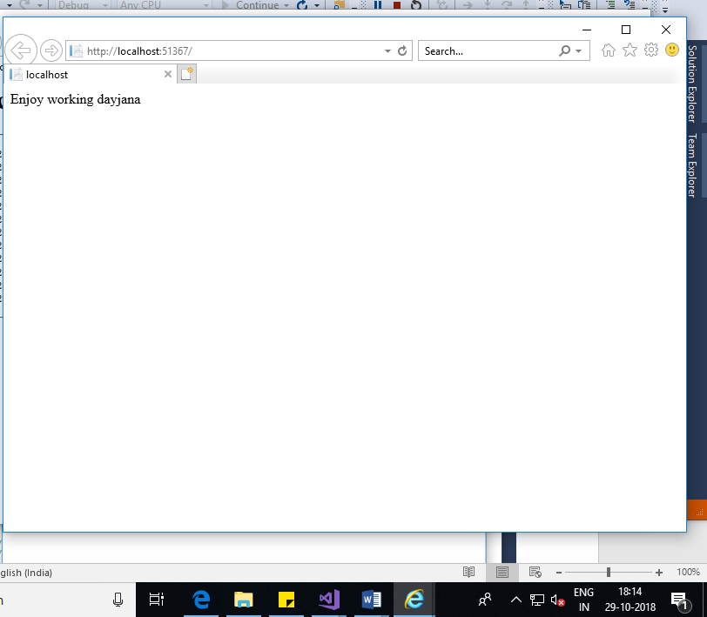

**Task 5:**

Deployed WebAPI_service application which you created in assignment_23

**Host the service in IIS**

**Steps:**

1. Type IIS in start search box and open
2. IIS will open as below

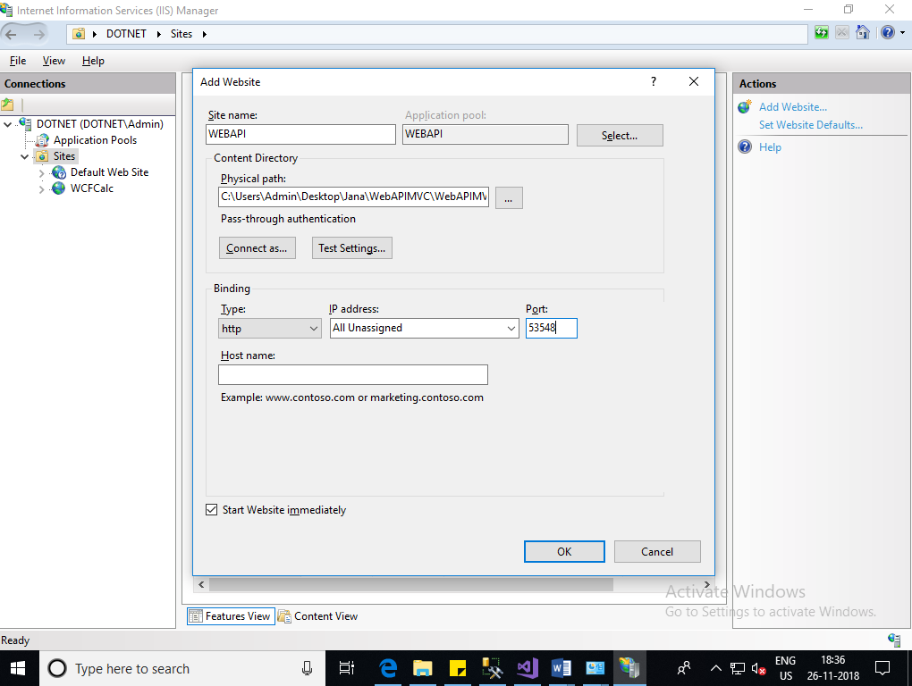

**Output:**

